UW-IT Wi-Fi Services Requirements Guide:

SERVICE INSTALLATIONS

*UW Facilities - Section 27 17 53 Wireless Communications*

CONTENT

Overview - UW-IT Wireless Services and Mobile Communications Requirements Guides

Requirements

R1 - UW-IT Wireless Services and Mobile Communications Change Reviews and Approvals

R2 - UW-IT Wireless Services and Mobile Communications Project-Related Communications and Coordination

R3 - Wi-Fi Service Installation Requirements

1. General Requirements for All Installations
2. Indoor Installations
3. Wall mount w/ right angle bracket
4. Wall mount w/ external antenna
5. Hard lid (drywall) ceiling
6. Drop ceiling w/ AP attached to junction box
7. Drop ceiling w/ AP attached to grid rail
8. Drop ceiling w/ AP attached to recessed grid rail
9. Exposed infrastructure
10. Under seat (floor)
11. Outdoor Installations
12. External on side of building
13. External on overhang/tunnel (i.e. horizontal facing down)
14. Rooftop installations w/ no poles
15. Pole installations
16. Power over ethernet (POE) and long-range connections

Process

P1 - Low-Voltage Contractor Qualifications and Qualifications Submittals

P2 - Input Materials, Information, Resources

P3 - Output Materials, Information, Resources

P4 - High-Level Installation Process Stages

OVERVIEW - UW-IT Wireless Services and Mobile Communications Requirements Guides

All UW projects for new construction and space renovations of 50,000 sq ft or more must incorporate the design and installation of the following Wireless and Mobile Communications Services:

WI-FI SERVICE - Service managed and operated by UW-IT Wireless Services Team.

PUBLIC SAFETY DISTRIBUTED ANTENNA SYSTEM (“PS DAS”) - Service managed and operated by EH&S with UW-IT Mobile Communications Team consulting.

CELLULAR DISTRIBUTED ANTENNA SYSTEM (“Cellular DAS”) - Service managed and operated by cellular carrier with UW-IT Mobile Communications Team consulting.

The following collection of requirements guides should help project participants better understand these services and how UW-IT Wireless Services and Mobile Communications teams are engaged and integrated into the overall project. While all guides should be helpful for the Project Manager, some are geared toward specific teams.

UW-IT Wi-Fi Services Requirements Guide: Project Management

* + Provides the UW Project Manager with information to help integrate the design and deployment of UW-IT Wi-Fi Services into the project plan.

UW-IT Wi-Fi Services Requirements Guide: Architecture and Engineering Designs

* + Provides the Wi-Fi Design Engineer with information needed to create and deliver a Wi-Fi service design.

UW-IT Wi-Fi Services Requirements Guide: Service Installations

* + Provides the Wi-Fi service installation team with information needed to install a UW-IT Wi-Fi service based on the final pre-installation design.

UW-IT Wi-Fi Services Requirements Guide: Post-Installation Surveys

* + Provides the Wi-Fi post-installation survey team with information needed to test the installed UW-IT Wi-Fi service to ensure it meets service standards and all vetted service requirements.

UW-IT Requirements Guide: Public Safety Distributed Antenna Systems (Public Safety DAS)

* + Provides EH&S and the Project Manager with information needed for the inclusion of a Public Safety DAS.

UW-IT Requirements Guide: Cellular Distributed Antenna Systems (Cellular DAS)

* + Provides the Project Manager with information needed for the inclusion of a Cellular DAS.

REQUIREMENTS

R1 - Required UW-IT Wireless Services and Mobile Communications Change Reviews and Approvals

Once service requirements have been collected and the service design process starts, any subsequent changes with the potential to impact the service requires review and advanced approval by the appropriate UW-IT service team before incorporation in the design and service implementation.

Service quality can be affected by many environmental and use-specific factors, all of which are considered in the service design process. Proposed changes to these factors - inclusive of customer requirements - after the onset of the design work will be reviewed by the UW-IT Wireless Services team or Mobile Communications team, as appropriate, and considered in the context of the overall design. Some of the many factors considered in the design include the following:

* architecture (e.g., new room, change in wall location, stairwells, elevators, etc.);
* environment (e.g., building materials, furniture, cabling);
* space type (e.g., office space, lab, auditorium);
* people using the service (e.g., students, medical staff, researchers, guests);
* devices (other than laptops, tables, and phones) using the service (e.g., cameras, freezers);
* apps using the service (e.g., Wayfinder);
* density of devices by location (e.g., 50 devices in small room vs 2 devices in large room);
* use profiles in each location (e.g., sporadic video streaming; students in large lecture hall simultaneously accessing Internet sites; big data uploads/downloads);
* appropriate RF frequencies;
* target delivery dates and project delays of six or more months which may require updates to equipment and equipment costs.

The UW-IT service teams appreciate your cooperative communication throughout the project regarding changes that have the potential to impact the resulting quality and delivery of the services.

R2 - UW-IT Wireless Services and Mobile Communications Project-Related Communications and Coordination

*Collaboration Space and Document Sharing.* At the outset of each project, a UW-IT Partner Project Services team member will create a dedicated online shared-access space where project-related information and documents can be accessed and managed by project team members. Documents in this space will include materials from the project’s architecture team; UW-IT forms related to service requirements and installation details; the service design package; and more as needed.

*Meetings.* Project team members are required to attend various meetings relevant to their roles and project coordination efforts. These meetings may include one or more on-site walkthroughs; pre-design requirements identification; post-installation review; and regular (usually weekly) project team meetings. Meetings may be called by the Project Manager, the UW-IT Partner Project Services team member, or other project team members. Each participating project team – UW teams and third–party contractors – must ensure that an appropriate team member and/or leader attend all required meetings. The designated meeting attendees will be informed and up to date on the status of their team’s responsibilities and work.

*Professional and Timely Communications.* Each project participant is responsible for appropriate and timely communications via email, document sharing, ticket systems, etc. If in doubt as to who to contact, send email to [help@uw.edu](mailto:help@uw.edu) and specify the project name in the subject line.

R3 – Wi-Fi Service Installation Requirements

1. General requirements for all installations:
2. To ensure optimal Wi-Fi service and performance, adhere to the provided pre-installation design developed by the Wi-Fi design engineer. Any installation deviations require advanced approval from the UW Wireless Services team.
3. Safety: Adhere to all work-safety procedures including but not limited to safety measures...
   1. specific to the physical environment (e.g., sterile areas, hazardous materials areas, etc.);
   2. associated with working on ladders and using power tools;
   3. related to working with low-voltage electrical systems;
   4. needed to protect persons and physical assets in the area.
4. Maintain a clean and organized work area throughout the installation - before, during, and at completion.
5. Use professional Wi-Fi installation techniques and only purpose-specific equipment and supplies. This includes using only connectors appropriate for the surface or component to which the equipment will be attached.
6. If needed, clean the exterior of the AP devices prior to installation.
7. Where required, ensure the installation meets project-specific aesthetic requirements for the location. E.g., certain locations that may require APs in enclosures painted a specific color; or custom mounting devices/enclosures may be needed to match the aesthetics of the environment.
8. Labels: Use a san serif font such as Calibri or Arial to make the label. The label height should be at least 18mm with the font filling most of this vertical space. Name labels for the APs need to be neatly attached to the face of the AP so it will be visible from the floor. Historically, there was no standard for where the label should be placed on the AP so various placements exist. To standardize going forward, the label should be placed vertically in the middle of the AP face which is often between the manufacturer’s name and the light. The label should also be centered horizontally on the AP with the alpha-numeric characters in the same orientation as the manufacturer’s name. Do not put the label over the manufacturer’s name. For APs installed above 10’ from the finished floor, ensure that the size of the font is sufficient for someone standing on the floor to read the label.

Example of standard label showing current required orientation and placement:

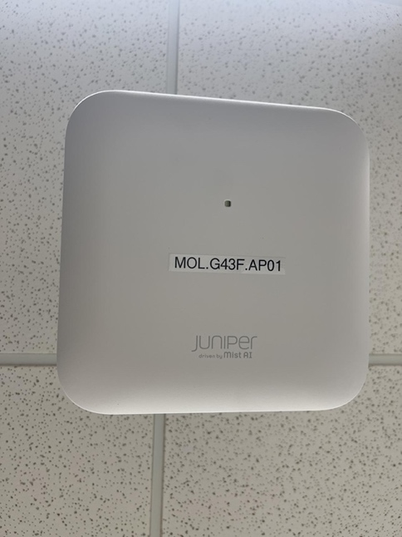

NOTE: for APs that are in enclosures, a label must also be added in a clearly visible location on the enclosure itself as shown on this example.

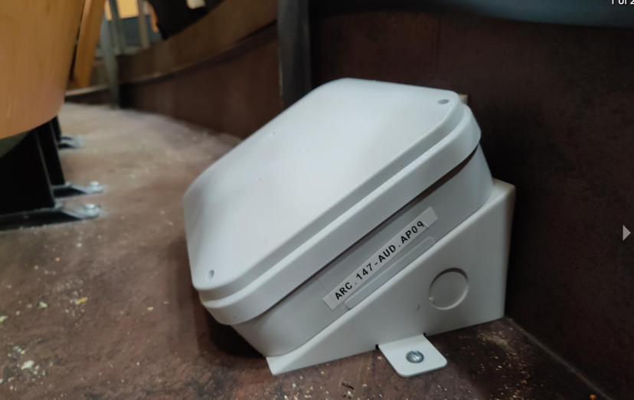

1. The design engineer should identify in the design any APs that are required to be installed beyond the allowable distance for POE. This is most likely to be the case for outdoor APs. In these cases, confirm in advance that the appropriate power solution has been deployed and is ready for the AP to be connected. See more information on this topic in section R3.C.4 below.
2. AP Orientation: The APs should be oriented with manufacturer’s logos consistently aligned throughout the floor; the initial alignment is modelled after the AP installed in the entranceway. The entranceway AP should be in a natural reading alignment for someone entering the main door and looking up at the AP. By virtue of how the APs are constructed and operate, the service quality is improved when APs are appropriately and intentionally aligned. See the diagram where the arrows represent APs with the logos all oriented in the same direction.

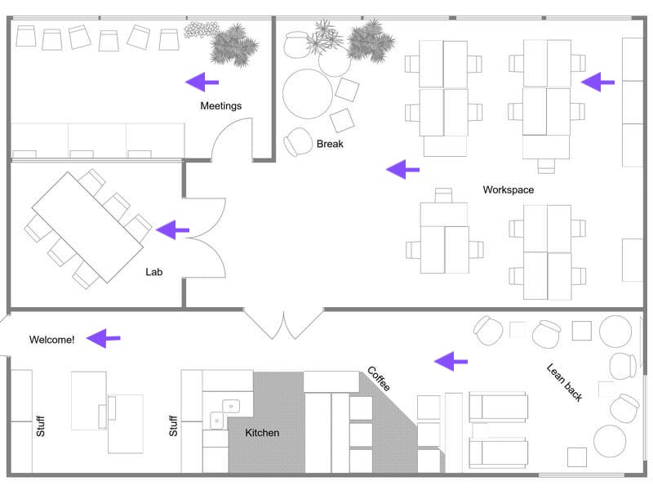

1. Wall-mounted APs inside buildings will typically be 8 feet above the finished floor.
2. Wherever possible, APs should be installed at least 2 feet from other installed devices such as fire alarms, location sensors, lights, etc.
3. For any ceiling mounted APs, the AP should be installed such that the AP is also level with the lowest hanging device in the vicinity.
4. APs installed on any type of dropped ceiling should be installed in a location where all adjacent panels are full-sized and have no other devices installed on them. This allows easier access for future maintenance and/or upgrades.
5. Ensure all installations minimize the visibility of patch cables connected to the AP: use appropriate length cables and where excess cabling is required, be sure it is neatly coiled and hidden.
6. Mounting plates must be secured as appropriate for the surface to which it is attached; in some cases, the plate will be secured directly to a surface with four screws (e.g., hard lid drywall), or it will be twisted to clip securely onto a rail, and in others it will be secured with four screws either to a bracket or a junction box. Always secure the plates using connectors appropriate for the surface or device to which the plate will be attached.
7. When attaching an AP to a mounting plate, slide the AP onto the mounting plate ensuring that it has been securely seated. This usually means ‘clicking’ the device into place. It should NOT be possible to slide it out again without disengaging the security tabs.

B. Indoor Installations

1. Wall mount with right angle bracket

* Right angle bracket should be secured to the wall as reasonably close to the data port as practical, but not more than one foot away from the data port.
* The bracket will be installed such that the flat surface of the AP will be parallel to the ceiling and the AP will be in the proper orientation. (See section R3.A.9 above regarding orientation.)

Example of standard MIST AP mounting plate:

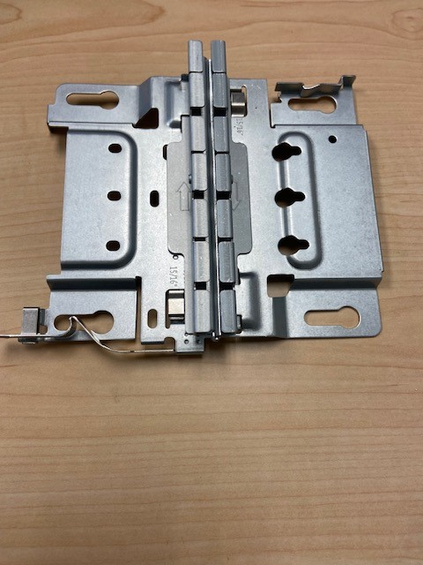

Example of wall-mounted AP using right angle bracket - close-up view and distance view:

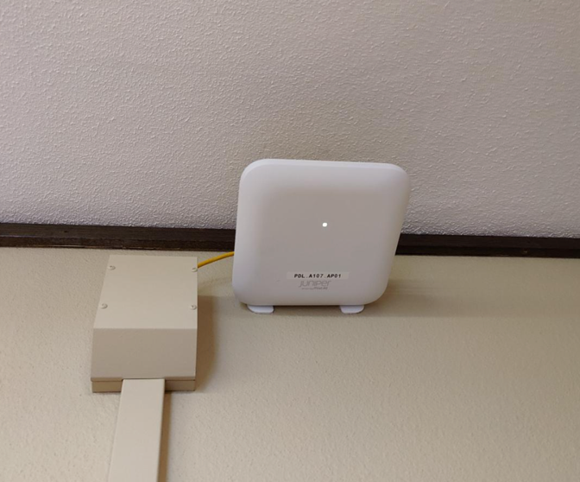

1. Wall mount w/ external antenna

a) There are three types of external antennas for use with indoor APs that may be encountered in a Wi-Fi service design:

* + 1. “Ducky” antennae that are secured on the AP itself;
    2. Cable-attached antennae that extend some distance away from the AP;
    3. “Patch” antennae that are placed ‘in front of’ or ‘on top of’ the AP itself.

b) Mounting options for APs with antennae are considered on a case-by-case basis. Please consult with the Wireless Services team about special mounting brackets and/or other attachment options.

i) “Ducky” antennae installations:

* + - APs requiring ducky antennae will always be wall mounted.
    - Each AP will have six antennae components attached. Each component has two parts:
      * Connectors. These are marble-sized roundish devices insert into appropriate jacks on the sides of the AP and into which the antenna rods are attached.
      * Antenna ‘rods’ that attach to the connectors. Once the antennae rod is attached to its connector, the connector component allows for ~180-degree hemispherical positioning of the attached antenna rod.
    - Unlike other wall-mounted APs, those with ducky antennae are attached vertically using an appropriate bracket. Do not use a right-angle bracket for these installations.
    - The vertically mounted wall AP will have the readable AP logo and label parallel to the ceiling/ground. The six antennae (three on top side and bottom side of the AP) will be oriented vertically up and down. The antennae rods must be aligned parallel to the wall and each other: the top three pointing directly up and the bottom three pointing directly down.

ii) Cable-attached antennae installations:

* + - Consult with the Wireless Services team regarding the details of these installations.
    - APs that require cable-attached antennae may be mounted in any location designated by the Wi-Fi designer.
    - In these cases, a shielded cable (much like a coax cable) of an appropriate length connects the antenna to the AP. The appropriately secured cable extends to the designated location.
    - Appropriate connectors and adaptors are required on both the AP and the antenna ends.
    - The antenna will be securely installed in the location designated by the Wi-Fi design.

iii) Patch antennae installations:

* + - Consult with the Wireless Services team for the details of all patch antennae installations.
    - APs that require patch antennae may only be mounted in locations designated by the Wi-Fi designer.
    - Special mounting brackets are required to secure, align, support, and connect the patch antenna with the AP.
    - Wall-mount examples:
      * Special brackets are available for wall-mounted APs with patch antennae.
      * Two “slot” wall brackets extrude further from the wall than normal wall-mounts. The AP is oriented ‘flat’ and parallel with the wall in the interior slot (vs perpendicular to the wall with a right-angle bracket) and the antenna is situated in the frontmost slot in front of the AP.
    - Exposed infrastructure example:
      * A threaded rod from the ceiling has a junction box on the lower end to which the AP is directly attached.
      * A special bracket sits ‘under’ the AP (closest to the ground) and the antenna is attached to this bracket.

1. Hard lid (drywall) ceiling
   * Ceilings with no airspace above and ceilings with airspace but no access hatch:
     + The data jack should be visible and accessible on the ceiling. Attach the AP mounting plate adjacent to the data jack on the ceiling and at least 2 feet from any other installed ceiling fixtures/devices.

Two examples of hard lid ceiling installations:

* + Ceilings with airspace (plenum or nonplenum) above and an access hatch to the airspace:
    - The data jack should be pre-installed within and at the top of the airspace area. A ¾" hole should be drilled through the room’s hard lid ceiling within two feet of the hatch and not more than two feet from other ceiling-installed devices. The patch cable should be threaded from the data jack through the ceiling hole – making sure that it does not impede opening of the hatch.
    - The AP mounting bracket should be at least 2 feet from any other installed ceiling fixtures/devices. Attach the AP mounting plate to the ceiling adjacent to where the patch cable comes out.

1. Drop ceiling w/ AP attached to junction box

* In advance of the AP installation, the junction box should be attached and secured above by spreader bars with clips. The downward face of the junction box should be nearly flush with the surrounding tile but allow for sufficient room to attach the AP mounting bracket. Once the AP is attached to the mounting bracket, it will appear as if the AP is mounted to the tile.
* Installation of the junction box should be on a full-sized tile that has no other devices installed on/in it.

Examples of AP installations with drop ceiling using junction box:

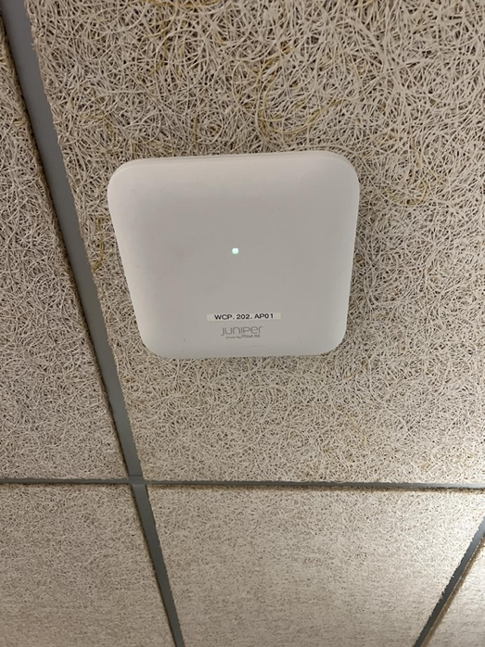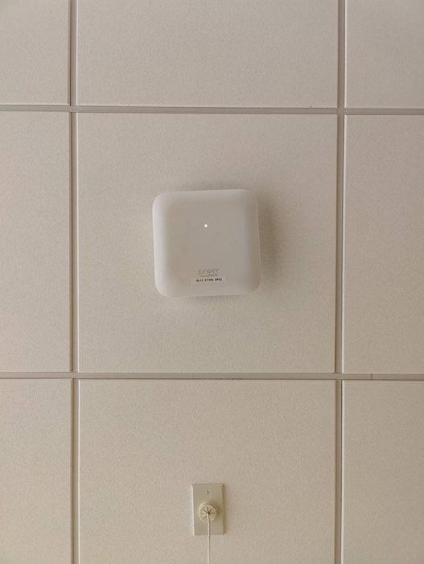

1. Drop Ceiling w/ AP attached to grid rail
   * The data jack will be on the ceiling above the grid. Create a ¾" hole in the ceiling tile adjacent to where the AP will be installed. Run the patch cord from the data jack through the hole.
   * The mounting bracket should be secured to the crossbar adjacent to the perforation made in the tile for the patch cable.

Example of AP installation on a drop ceiling w/ grid:

1. Drop Ceiling w/ AP attached to recessed grid rail
   * The data jack will be on the ceiling above the grid. Create a ¾" hole in the ceiling tile adjacent to where the AP will be installed. Run the patch cord from the data jack through the hole.
   * Insert the T-adaptor on the desired rail.
   * The mounting bracket should be fully secured to the T-adaptor on the crossbar adjacent to the perforation made in the tile for the patch cable.

Example of t-adaptor and Juniper MIST AP mounting plate with T-adaptor attached:

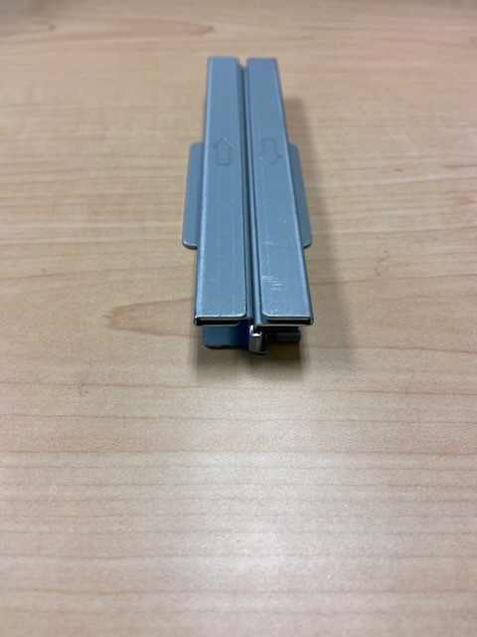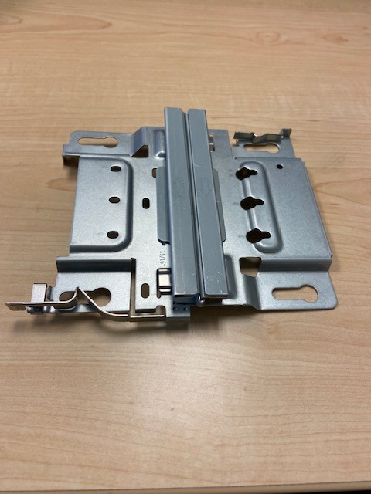

Example of AP installation on a drop ceiling w/ recessed grid. The first photo shows the mounting plate with t-adaptor installed on the tile. This installation keeps the tiles level in their normal orientation. The second photo shows the AP installed, again allowing the tiles to be properly seated.

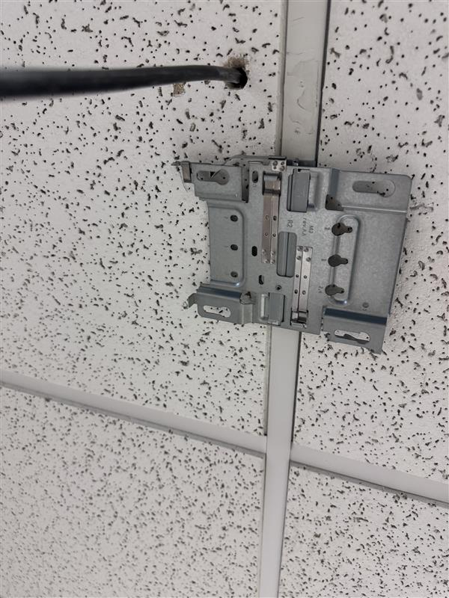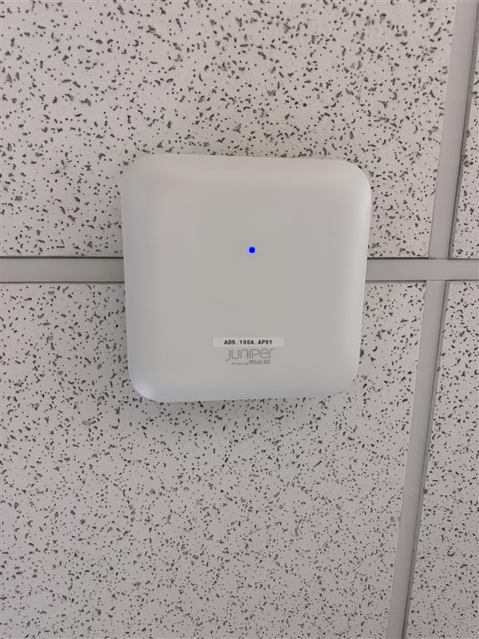

1. Exposed infrastructure

Exposed infrastructure environments are extremely varied and may be a result of aesthetic design decisions or functional decisions. For example, a design that intentionally exposes heating ducts, cabling ducts, and overhead lighting mounts in an area that is designed for use by many people (e.g., an auditorium) is very different from a power plant or a machine room which is designed to house HVAC equipment, batteries, or fire suppression equipment.

Depending on the location, APs may be installed using universal strut options available in the overhead space; or via threaded rods with junction box and data port attached from the ceiling; or the designer may opt to use a right-angle bracket for a wall-mounted solution.

Before installing APs in these situations, understand the solution as outlined in the design and confer with UW-IT Wireless Services team in advance.

For APs that will be mounted overhead and not on a wall with a right-angle bracket:

* + The installed AP should be at least two feet away in all directions from other devices and infrastructure (e.g., lights, pipes, conduit, etc.) AND should not be higher off the floor than any other device or infrastructure in the vicinity;
  + APs ideally will not be more than 10’ above the finished floor; however, the AP placement needs to be such that normal activities can occur underneath. For example, in a warehouse area that uses a 15’ forklift, the AP needs to be above 15’.
  + For APs that must be installed higher than 10’ feet above the finished floor, the device name label on the AP must be printed in a much larger font so that it can be read by a person standing on the floor.

Example of exposed infrastructure mounted APs using threaded rod with junction box in first photo; beam attachments in second photo:

1. Under seat (floor)
   * Floor-mounted (usually ‘under seat’) AP installations require use of a NEMA (National Electronics Manufacturers Association) box, security screws to attach the lid, and metal flex or liquid tight ‘piping’ through which the jumper cable comes from the data port into the NEMA box.
   * Although flat NEMA boxes have been used heavily in the past, angled NEMA boxes are now the UW-IT standard.
   * The NEMA box must be secured with appropriate anchors to the floor.

Example of under-seat (floor) mounted APs in angled NEMA enclosure:

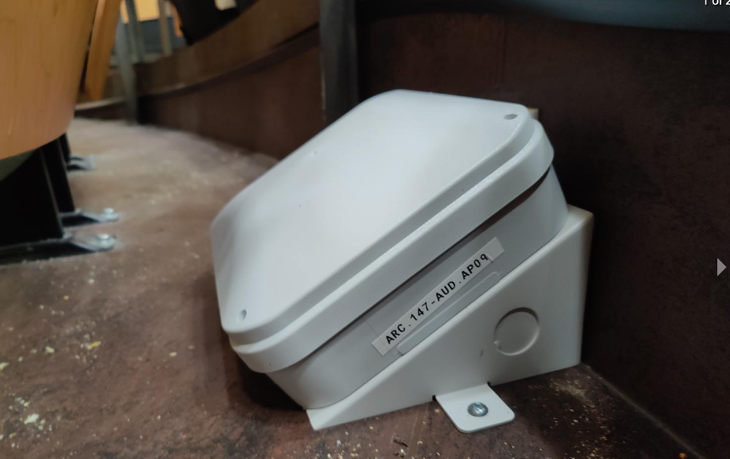

C. Outdoor Installations

Many details of outdoor installations tend to be specific to each situation and can include type of outdoor-rated AP, whether an external antenna is needed, location (e.g., roof, light pole, side of building, in an open space area), aesthetic requirements, as well as distance from interconnect. Installation-related details will be provided with the pre-installation Wi-Fi design.

1. External on side of building

Example of an external outdoor AP installation, no antenna:

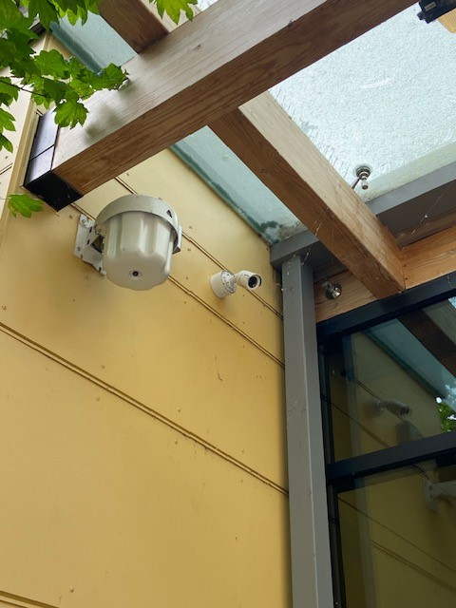

1. External on overhang/tunnel. (i.e. horizontal facing down)

Example of outdoor overhang installation of outdoor-rated AP with built-in antenna:

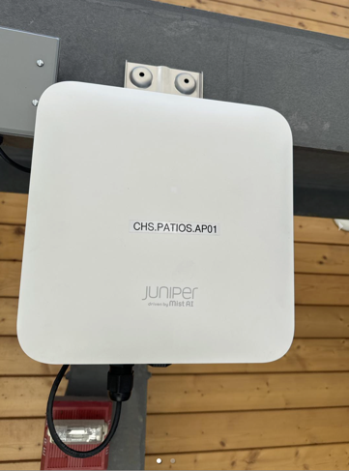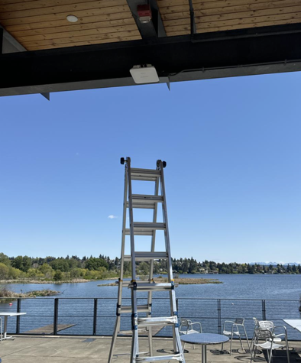

1. Rooftop installations w/ no poles

Some rooftop installations may have solutions that allow the AP and, where needed, antenna to be installed using appropriate brackets and/or arm mounts.

Example of rooftop installation where the AP is mounted on an enclosure with data jack and the antenna is attached on an arm mount:

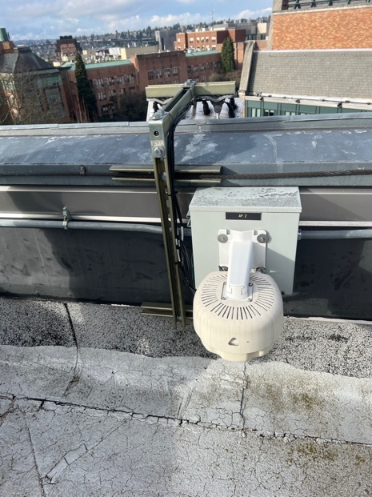

1. Pole installations

There are a variety of different pole installation types. Included here are the most common ones at UW.

* + - Plain, unpainted, vertical metal poles on which there are not likely to be any other non-wi-fi devices attached. The AP is attached using metal pole straps and the properly sheathed, secured cabling is run on the outside of the pole. This is commonly used when installing APs on a rooftop where the antenna component needs to be raised well above surrounding structures. In these cases, aesthetics of the installation not seen from the ground are usually not an issue.

Examples of rooftop installations on metal poles including APs and antennas:

In the first two photos of two different installations, the APs and antennas are visible in the photos. In the third and fourth photos of a single installation, this AP has a built-in antenna. In the fifth photo, only the antennas are visible.

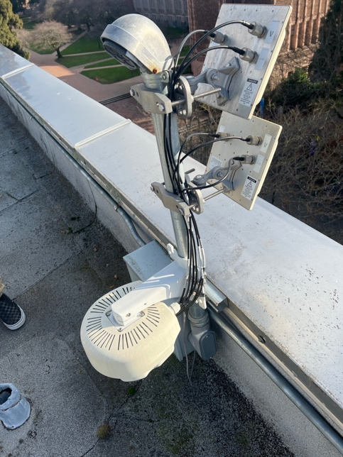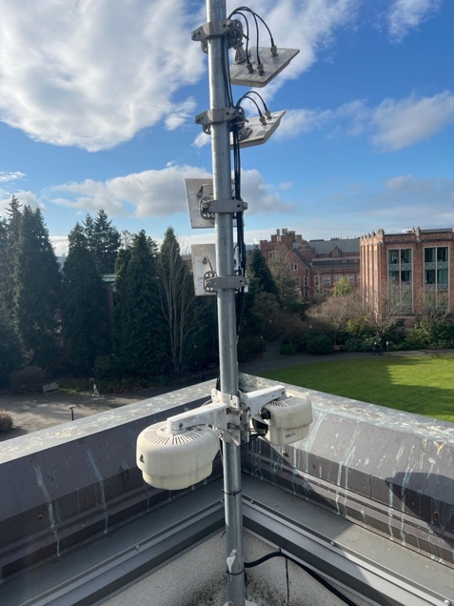

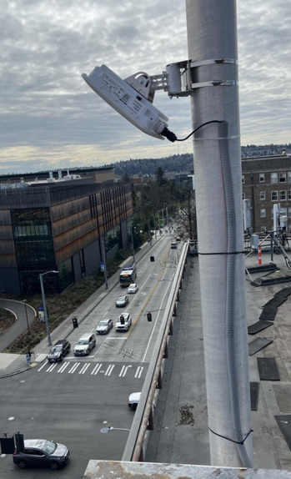

* + Standard light poles with in an inverted “L” shape are commonly called “cobra poles.” APs attached to a cobra pole will usually be installed 15’- 20' above the ground. In most cases, these will not require an antenna.
    - POE cabling is typically accessed via the bottom of the pole through a standard access cover. A single hole will need to be drilled in the pole so the cabling can be threaded up the inside of the pole and then attached to the AP. If there is extra cabling, it should be neatly coiled and left inside the pole.
    - The AP should be attached to the pole with metal straps. The drilled hole for the cable should be directly above the AP bracket.
    - While these installations do not usually have stringent aesthetic requirements, it is always important to minimize the impact on the underlying pole structure by drilling only necessary holes and always ensuring a neat and secure attachment of the AP.

Example of a cobra pole AP installation:

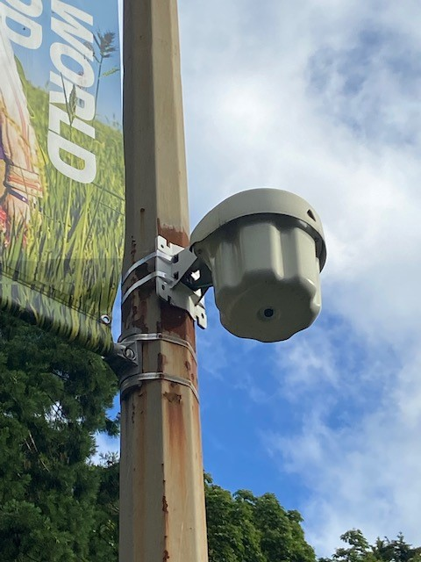

* + Minimizing visual impact of the installed AP can be a requirement in areas where the AP will sit within the sphere of a structure’s or area’s designed detail. For example, the architectural design of some buildings will extend to light poles specific to the building. In other cases, special light poles may be installed in park settings. In either case, a common minimum requirement is for the AP enclosure to be painted to match the light pole. However, it may also include a requirement for custom mounting solutions and a custom paint job.

Examples of two different specialized AP installations on light poles:

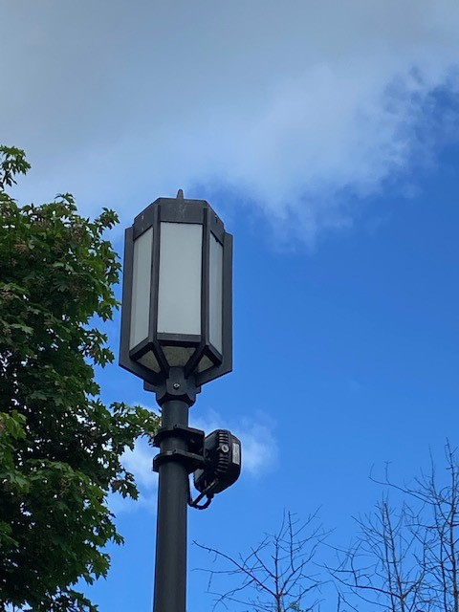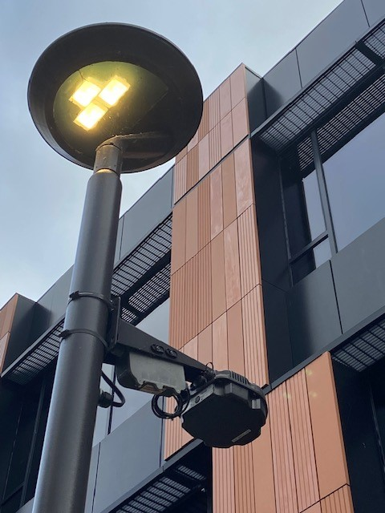

1. Power over ethernet (PoE) and long-range solutions

Outdoor APs are often well-beyond the maximum 100m range for standard Power over ethernet solutions. Alternative, integrated commercial solutions for long-range situations offer a power supply, specialized bundled cabling (copper plus fiber) and POE extenders with which to connect and power the AP. The UW-IT Communications Infrastructure (CI) team will be responsible for approving a cabling solution for outdoor APs. While this solution will be installed separately from the AP installation itself, the AP installation team will need to be prepared for these types of AP connections.

PROCESS

P1 - Low-Voltage Contractor Qualifications and Qualifications Submittal

The low-voltage contractor must meet the following qualifications and submit evidence of qualifications prior to starting the work:

* Demonstrated ability installing Wi-Fi networks using the equipment specified in the design.
* Been in the wireless network installation business for a minimum of five (5) years.
* In terms of size and cost, contractor will have successfully completed at least five (5) comparable wireless installation projects within the past three (3) years.
* Ensure and warrant that all installations meet the manufacturer’s specifications as well as applicable requirements, standards and regulations from UW, local, state and federal agencies.
* Employ individuals fully familiar with and qualified to install the designated Wi-Fi equipment and who can complete the installation and provisioning process per the Wi-Fi Installation Requirements Guide.
* Use only full-time permanent employees of the Contractor to perform all work related to the installation and deployment of this Wi-Fi service.

Submittal of contractor qualifications must be provided not more than two weeks in advance of the installation project start date and not later than the onset of the work. As the details of these qualifications may change throughout the work (e.g., new contractor staff are brought in and others released), the contractor is responsible for providing timely updates to qualifications.

P2 - Input Materials, Information, Resources

Pre-Installation Wi-Fi Design Package which includes the following:

* The Wi-Fi Information Form (WIF) with all relevant necessary pre-installation information completed.
* The completed Wi-Fi Service Order Intake Form.
* Iterative and final pre-installation design drawings – electronic and paper.
  + Pre-installation design report from the Wi-Fi designer.
  + If needed, electronic CAD files of floor plans with AP placements: DWGs and derived PDFs (to be provided by the project’s contracted architect, not the design engineer)
  + If requested, ANSI B 11”x17” (Tabloid-sized) paper printouts of the PDF design files.
* Coverage and capacity maps drafted with a commercial-grade Wi-Fi site design and survey tool (e.g., Ekahau) in each of 2.4Ghz, 5Ghz and 6GHz ranges.
* A complete bill of materials (“BOM”) for all components of the design, including, but not limited to:
  + Wireless Access Points (APs).
  + Hardware required for proper installation and mounting of APs.
  + External antennas including related mounting and installation hardware, as required by the design.
  + Lightning arrestors, mounting poles or other equipment required by the design.
* APs and AP enclosures with appropriate UW-IT labels affixed

P3 - Output Materials, Information, Resources

* Final completed WIF (Excel File)
* Installation site photos (2-3 photos per installed AP showing installed AP close-up; from a distance of ~10 feet; and if applicable photos of the installed enclosure)
* Paper copies, as applicable, of the Pre-Install Design layouts with hand-written notations of variances and pre-approved changes OR electronic file providing notations on approved, installed changes.

P4 - High-Level Installation Process Stage

1. Ensure the UW-IT project collaboration space is accessible to the installation team along with access to the project’s Wi-Fi Information Form (“WIF”).
2. Request and participate in project meetings as coordinated and scheduled by project leads e.g., Project Manager, UW-IT Technology Manager, UW-IT Partner Project Services team member. These meetings should include 1) pre-installation meeting; 2) pre-installation site walkthrough; and project team meetings usually held weekly.
3. Receive and review the UW-IT approved Pre-Installation design from the Wi-Fi design engineer. The design materials will reflect the details for the approved implementation – location, equipment, configuration. If requested by the installer, a paper copy will be used during the installation process by the installation team to note any relevant info and to record any UW-IT approved changes applied during the installation process. Otherwise, the installer will prepare a separate electronic file (e.g., Word) to track the changes.
4. Work with UW-IT (Partner Project Services team member and/or Communications Infrastructure team) to ensure that the cabling needed is in place for the build.
5. Work with UW-IT (Partner Project Services team member and/or Network Implementation Team) to ensure that the following have been addressed prior to installation: AP licenses and license reservations, controller configuration, DHCP pool capacity; availability of switch ports; and that this information has been appropriately entered into the NIM teams' portion of the WIF. NIM is also responsible for ensuring that the Wi-Fi subnets are configured on the appropriate routers and that there is sufficient Power over Ethernet (PoE) for the new devices on the switches.
6. UW-IT purchases the hardware based on an approved BOM associated with the Pre-Installation Design. Confirm with UW-IT that the equipment is available and arrange to pick up the equipment. NOTE: hardware substitutions are not allowed without the advanced approval of UW-IT.
7. Label APs and AP enclosures with the appropriate AP name as documented in the design materials. Record the MAC address and name for each AP in the WIF.
   1. NOTE: when labeling the APs, use appropriate label and font sizes so the label can be easily read from a standing position on the floor. This is especially important for APs that may be installed 10’+ feet above the ground
8. Where information has not been documented by NIM, make appropriate updates in WIF: document AP make and model; device name; physical service locations where they will be installed; MAC addresses; associated switch connection details (switch tag number, IP, port, location).
9. Confirm with NIM that any necessary pre-install provisioning for the new APs, Wi-Fi management utilities, internal operational databases has been completed.
10. Work with the UW-IT Partner Project Services team member regarding days/times for installation work; coordinate with the UW-IT Network Implementation Team (NIM).
11. Deploy hardware. Take 2-3 photos of every AP installed: 1) a ‘front on’ view of the full, installed AP with the AP name clear and visible; 2) a photo of the installed AP from about 10’ away showing it in the environment; and, if applicable 3) a photo of the installed AP enclosure clearly showing the contextual orientation of the installed device.
12. Inform PM, Wireless Services Team, and NIM about the installed APs. Update the WIF.
13. Any deviations required and approved during the installation process should be documented and delivered to the UW-IT Wireless Services team. The UW-IT Wireless Services Team will enter the changes into the design tool to finalize the electronic version of the ‘as built’.