Thrive Messages in MyUW: Year 1 Report

Authors: Janice Fournier & William Washington
Academic Experience Design & Delivery
UW Information Technology

Introduction
During the 2015-16 academic year, UW Information Technology partnered with the Office of the Provost and Undergraduate Academic Advising (UAA) to send weekly messages to first-year students via MyUW, the University’s portal for personalized information for UW students. The messages were the principal component of the Thrive Initiative and were developed by UAA with input from faculty, advisers, and experienced students, as well as other campus units. The messages provide advice and pointers to help first-year students explore opportunities, make the most of their learning experiences, and connect to important campus resources.

UW-IT proposed MyUW as a delivery channel because students frequently access the site for administrative information they need (Husky Card balance, class schedule, textbook requirements, registration deadlines, etc.) Recently redesigned, the new MyUW is mobile-friendly and structured to deliver dynamic content. Our research for the redesign found that the needs that drive students to the site are predictable and cyclical. Consequently, the new MyUW highlights different information for students at different times throughout the quarter, presenting it on a “card” (a visual container for content) front-and-center on the main page. For example, registration resources are highlighted the week before registration begins; the Final Exam schedule, while always available, is highlighted on a card the days before and during final exam week. Although the #ThriveUW messages were a departure from the type of content normally displayed on MyUW, the platform was ideal, and the messages provided an opportunity to test delivering timely content targeted to a specific group of students.

For the Thrive messages, we designed a content card to appear to first-year students at the very top of the MyUW main page. The card included a consistent “#ThriveUW” header and headers indicating the message topic, “Try This,” and “For More Help”; the content under these headers changed week-to-week. The goal of this design was to make the card easy for students to scan, to provide discreet and digestible chunks of information, and to prime students for the type of information that followed—the main message, an action to try, and additional resources. In both format and design, the Thrive card was consistent with the look and feel of other content on the MyUW site.

Figure 1. Original Thrive Card Design
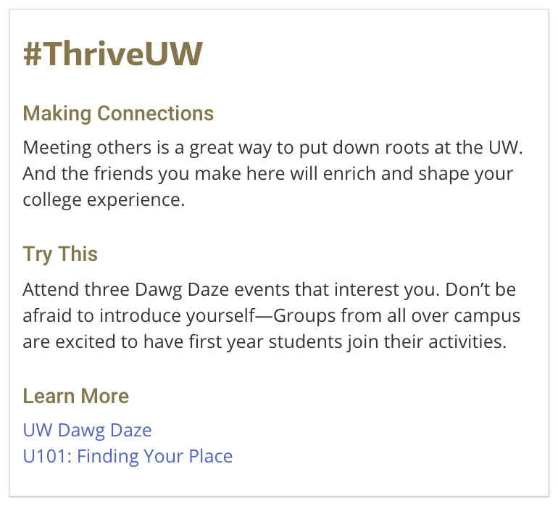

Messages were also shared with FIG leaders and RAs, who were encouraged to address or elaborate on the topics around the same time the messages appeared in MyUW. These efforts were not assessed, so we do not know how effective they were in providing awareness of the content in MyUW. This report covers only what we learned in regard to dissemination of the Thrive messages through MyUW.

Assessment
Assessment of this effort included a survey (our main data collection instrument) and analysis of log data. We designed the survey to understand:
- Whether students found value in the messages
- Whether MyUW was an effective platform for delivery
- Whether the visual design of the content was effective
We sent a survey invitation via email to all students receiving Thrive messages in MyUW (n=6982) in Week 3 of spring quarter; we had a 15% response rate (n=1077). The survey reminded students of message content they had received in autumn and winter quarters (see Appendix A).

We also collected log data on MyUW servers to track which links students followed from the messages, if any. Visits to MyUW, called sessions, and any links clicked on during a particular visit were recorded. Logging and analyzing session data was a way to capture actual student behavior that we could compare to self-reported behavior on the survey. By themselves, records of links clicked cannot tell us why students accessed a particular link, or whether they found it useful. But taken together with survey responses, the log data helped paint a more holistic picture of student behavior and information needs.

1. Survey Results
1a. READERSHIP
Data from the survey confirmed that students access MyUW frequently; 92% of respondents reported that they log in at least once a week, 43% reported that they log in daily.

Despite the frequency with which they log in to MyUW, many students did not notice or read the Thrive messages.
- 55% of respondents reported that they read the messages (read almost all the messages, read some, or skimmed)
- 45% of respondents reported that they did not read/did not notice the messages

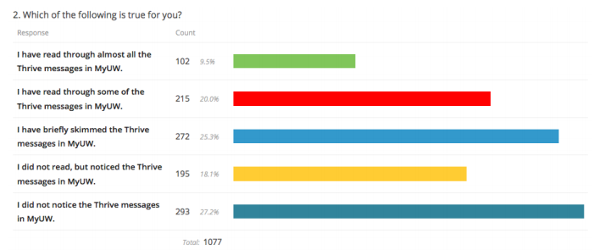

We conducted a further analysis of the data to understand if and how survey responses from students who lived in residence halls and/or participated in a FIG differed from students who neither lived in a residence hall nor participated in a FIG. The only significant difference was in readership: Students who did not participate in a FIG or live in a residence hall were less likely to have read or noticed the Thrive messages (x2(12) = 27.494, p = 0.007) in comparison to students who did have one or both experiences.

These differences are most apparent when responses are grouped into “Readers” (those who read almost all the messages, read some, or skimmed) and “Non-readers” (those who did not read/did not notice the messages).

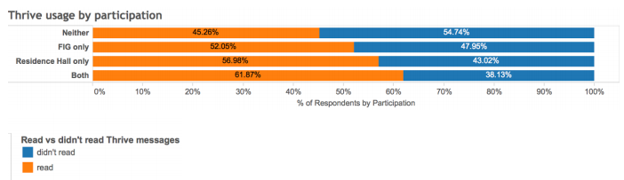

We cannot account for this difference in readership. It may be the result of FIG leaders and RAs making their students aware of the Thrive messages in MyUW, or from greater engagement on the part of students who choose to live in the dorms or participate in FIGs, or for another, unknown reason. The survey data is not definitive in this regard.

The survey branched after the readership questions; those who read the messages (read all, some, or skimmed) received one set of questions, those who did not read/did not notice received another.

1b. MESSAGE VALUE
The vast majority (93%) of students who read the messages (Readers) rated the content “somewhat helpful” or “very helpful.” Only 1% reported that they found the messages annoying.

In addition, 91% of students who read the messages rated them as “somewhat well-timed” or “well-timed.”

When asked what actions they had taken in response, Readers most frequently reported clicking a link (46%) or trying a suggestion (36%).

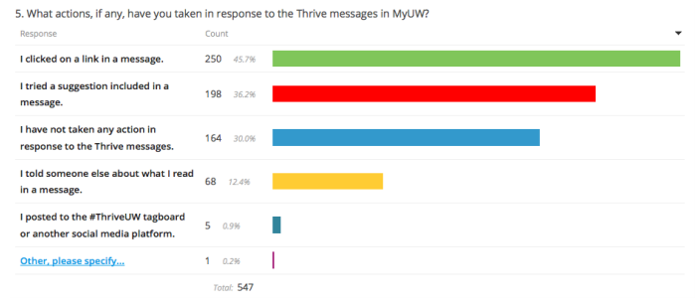

Near the end of the survey, Readers were asked if there was anything more they wanted to share about their experience with the Thrive messages. Of the 116 students who responded, 50% (58) wrote comments expressing appreciation for the messages.
Very encouraging...helps me realize that UW knows a little bit about what I'm going through.
These tips are great and helpful when finals come around and there is a lot to deal with such as stress and studying.
It reminds me of the things that i should think about and should be doing.
It has been a little helpful boost in some weeks.
They gave me a nice boost of motivation and it was refreshing to see messages on my homepage that was not just school/class info.

Readers were asked which messages from autumn and winter quarters they remember being helpful.
- More frequently selected were messages that focused on practical advice about studying and academics, dealing with stress, and managing time and money (>25% of respondents selected these topics).
- Less frequently selected as helpful were messages related to libraries, leadership, roommates, and explorations (<15% of respondents selected these topics).
Both groups (Readers and Non-readers) were presented a list of the message topics and asked which messages they would like to access and read again, or for the group that did not read them, which messages they would like to access and read now. The groups chose very similarly. Again, responses showed a clear preference for content related to studying/academics, internships, stress reduction, and managing time or money. Least popular was content relating to libraries, leadership, and roommates.

1c. MYUW AS A DELIVERY PLATFORM
MyUW emerged as the preferred option for message delivery for both Readers and Non-readers.
96% of Readers reported that they wanted to receive Thrive messages either “in MyUW” or “in MyUW and also…” For those who selected “in MyUW and also…” the most popular additional option was email (65%).

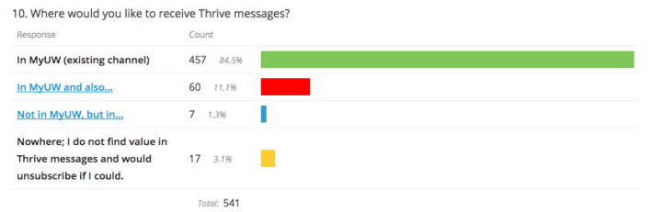

Non-readers were asked, “Is there a better way for you to receive helpful tips and advice than in MyUW?” Of the 320 respondents to the question, 30% wrote in “No” (MyUW is the best option) while 40% wrote in “email.”

That being said, survey respondents also told us that they are accustomed to using MyUW as a utility application; they go to it for specific administrative information and to complete tasks. Many students (both Readers and Non-readers) reported that they just scrolled by the messages because they were accessing the app for a different and more pressing reason.
Most of the time, looking at Thrive messages is not the reason why I logged onto myuw
MyUW was more of a tool than anything, so when I logged in I was always focused on getting to what I needed- class schedule, textbook list, etc. I wouldn't mind the option of receiving the messages via email.
When I go onto MyUW I don't go on there to look for advice. I go to get stuff done.

1d. THRIVE MESSAGE FORMAT
Both students who read the messages and those who did not were asked similar open-ended questions about how to improve the design of the Thrive messages.

Readers were asked, “Do you have any suggestions for improving the format of Thrive messages in MyUW?” Of the 177 responses, 66% wrote in that they did not have suggestions or wrote “no, keep it up,” while 32% made suggestions related to visual design.

Non-readers were asked, “How could the format of Thrive messages in MyUW be improved to encourage students to read them?” Of the 320 write-in responses, 56% related to visual design.

The visual design suggestions were consistent across both groups and included
- Change the color of the messages (to make them “more eye-catching”)
- Make other changes to make the message “stand out” in MyUW
- Include images (photos, info graphics, video) as part of the message
- Make the message the header and not “#ThriveUW”
Because of the consistent header and the way the Thrive messages blended into the design of MyUW, many students reported that they did not notice that the messages changed week to week.

1e. OTHER SOURCES OF MESSAGE CONTENT
Almost all survey respondents indicated that they had heard advice similar to the content contained in the Thrive messages from different sources—from orientation and the U101 course, residence hall advisers, FIG leaders, faculty members and TAs.

Only a few students noted in comments that the repetition was unwelcome.
The format is very well designed. The only reason I don't read them often is because I've already heard the message.

Other students expressed a preference for hearing the advice from people they knew.

I personally like it when my professors give us tips. We're already in class…
Have faculty start class with one [Thrive message]
Besides going to advisors MyUW is very helpful.
In person, from accessible members of the UW Community
Actual advisors maybe.
I think the best way to receive tips and advice is to get around and talk to people in person.
Friends who have been through my situation.

1f. ADDITIONAL SURVEY FINDINGS
In other open-ended questions, Readers and Non-readers provided additional feedback on the content of the messages and other aspects of the Thrive Initiative. Findings from these comments are summarized below.

Message Specificity: Students wanted information in messages that went beyond “common knowledge;” they asked for “more facts” and specific actions they could take. Several asked for more links to resources.
[I want to know about] specific events going on, specific study tips.
[The messages] seem to be just the same old thing I've heard many times–advice based on common sense or common knowledge. Those can be a little annoying. However, the ones that are more unique and original are really nice.
For me, many of the tips in the Thrive messages are general and not something I haven't heard before. Directly linking to helpful websites could be more useful to students.
There should contain more ideas to try out in order to be a better university student. Instead of saying "go out and try something different this week," try to give multiple suggestions.

Message Tone: Several students commented on the tone of the messages, describing them as having a “trite” or parental tone.
Be less patronizing.
Make it less cheesy....Maybe make it humorous and less condescending.
Don't be so square.
More specific advice that’s not trite.
Make it more real, not fluffy words and tips we already know.
Try to speak on a more casual level so it feels like a student on student conversation

Thrive Hashtag: Students expressed a strong negative reaction to the hashtag, #ThriveUW.

Remove the hashtag.. makes me not want to continue reading
Take out the hashtag, it's too cheesy.
Get rid of the hashtag. Usually when I see a hashtag I think it's a promotion so I skip it.
I tend to read [the hashtag] as unofficial and thus not particularly relevant to me.
I dislike the hashtag, it for me kind of minimizes the message for some reason. I end up ignoring everything else underneath.
One finding outside of the survey was that the social media component of the initiative was not well utilized; few students followed the link to the #ThriveUW tagboard from MyUW and fewer posted on the tagboard itself.

ThriveUW Marketing: Many students reported that they did not pay attention to the messages because they did not know what ThriveUW was.
I did not know what thriveUW was beforehand. I had seen it in myuw but I wasn’t exactly sure what it was implying.
I think most people don't know what thrive is so that's why they disregard the messages
I would delete the Header because "ThriveUW" does not mean anything to me— it hasn't been branded, and as a regular student I do not want have to dedicate more time to figuring what it is about.

2. Log Data Findings
2a. READERSHIP AND CLICKS
Log data reflects click activity, but does not indicate whether or not content is actually read; this is a known limitation of measuring user behavior on the web.

In our analysis of log data, we found that click activity indicated a low degree of engagement with the Thrive resources. There were over 6,000 first-year students, and the most frequently accessed resource was clicked a total of only 278 times during the week that it was displayed. However, data from the log files show that students accessed Thrive resources consistently throughout autumn and winter quarters (the two quarters we measured), indicating that over time, students did not experience message fatigue.

Figure 2. Total number of times Thrive resources were accessed each month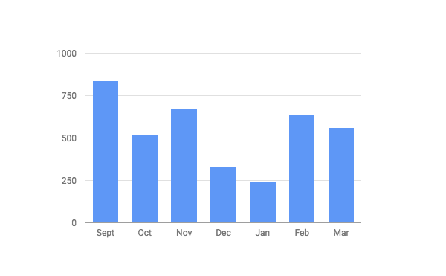

2b. MESSAGE VALUE
While an analysis of click activity does not indicate what value students placed on the Thrive messages, it does indicate students’ level of interest in individual resources. Each Thrive message included multiple links to resources under the header “Learn more.” To understand which Thrive resources were most popular, we normalized the data to account for weekly variations in traffic to MyUW.

The most popular resources as indicated by the log data related to studying/academics, internships, stress reduction, and managing time or money—the same message topics that students reported most valuable on the survey. As shown in the table below, other popular resources indicated in the log data included those on “fitting in,” resources about co-curricular activities, and resources about health topics.

Thrive Resource | Theme
AU7: Adviser-suggested courses | Fitting In
AU7: Adviser-suggested courses | Studying and Academics
WI7: MyPlan Academic Planning Tool | Studying and Academics
WI10: Proven Tips for Finals Preparation | Studying and Academics
AU10: 6 Money Tips for Students | Managing Time or Money
AU0: U101: Finding Your Place | Fitting In
WI9: Summer Study Abroad | Co-curricular Activities
AU8: Meyers-Briggs personality assessment | Fitting In, Studying and Academics
WI9: CoMotion Summer Internship Program | Co-curricular Activities
AU6: Tips for getting good sleep | Health
AU4: UW CLUE study tips | Studying and Academics
AU5: UAA Advising | Studying and Academics
WI6: UW Internship Fair | Co-curricular Activities
AU11: Preparing for tests | Studying and Academics
AU1: Apps for time management | Managing Time or Money
WI6: Learn about Internships | Co-curricular Activities
WI10: IMA Hours | Health
WI8: Light Therapy for Seasonal Affective Disorder | Health
Table 1. Top Third Most Popular Resources

Log data also indicated that resources relating to libraries, leadership, roommates, and activism were the least popular in terms of click activity. Again, the data echo similar results from the survey; students showed the least interest in accessing and reading again messages on these same topics.
In addition, the log data indicated that within each week, students accessed some resources more frequently than others, suggesting that they found these resources more interesting or potentially useful. The following charts illustrate three sample weeks and the percentage of clicks received for each resource displayed with the message.

Figure 3. Percentage of clicks on each resource, wk 7 autumn qtr

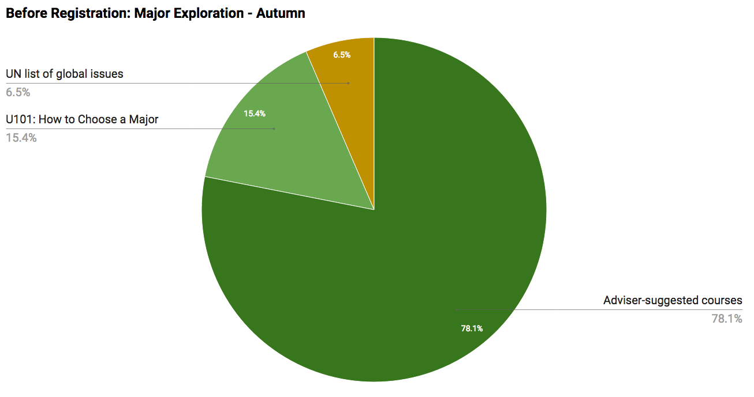

Figure 4. Percentage of clicks on each resource, wk 7 wtr qtr

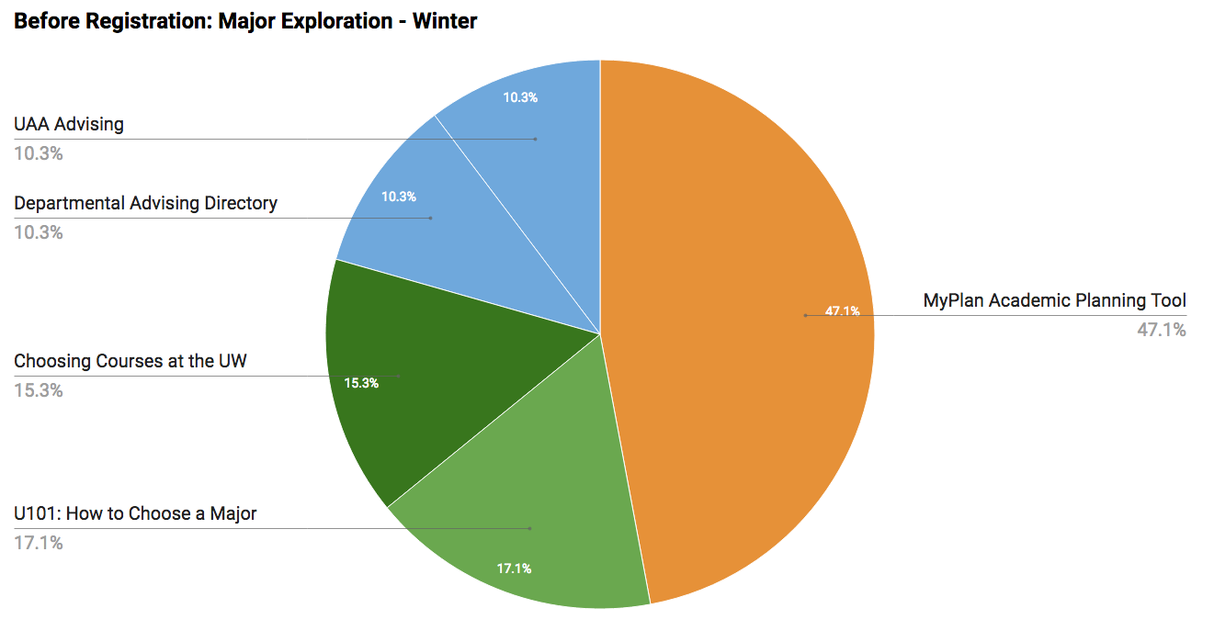

Figure 5. Percentage of clicks on each resource, wk 10 wtr qtr

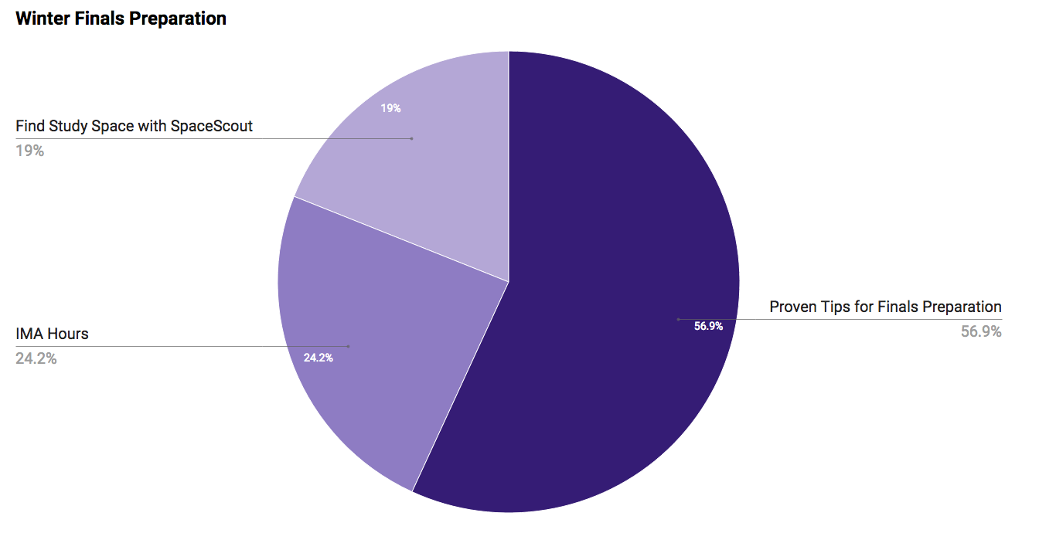

2c. MYUW AS A DELIVERY PLATFORM
To understand the low degree of engagement with Thrive resources, it helps to compare the Thrive log data with log data from other delivery platforms, such as email newsletters.

We analyzed log data from the student versions of the UW-IT Connect September 2016 and October 2016 newsletters, which were sent to the entire student body. Although the population for the newsletters is not identical to the population for the Thrive messages, these newsletter logs provide the best record of student behavior that can be compared to the Thrive data.

“Click rate” is the measurement we used to compare MyUW as a delivery platform to the IT Connect newsletters. We calculated the click rates for MyUW and the newsletters using the formulas below.

MyUW |  | Newsletter
Click rate = | # times link displayed  # clicks on that link | Click rate = | # people who opened newsletter  # clicks on that link

As a delivery system, MyUW appears to be twice as effective as a newsletter. For links in the September newsletter the click rate average was 0.17% (standard deviation of .21%), and the most popular link had a click rate of 0.67% (234 clicks out of the 35,055 that opened the newsletter). In the

October newsletter the click rate average was 0.14% (standard deviation of 0.38), and the most clicked link had a click rate of 1.7% (525 clicks, with 31,328 students opening the newsletter). In comparison, Thrive links in MyUW had an average click rate of 0.33% (standard deviation of 0.41%). The most popular Thrive link in MyUW had a click rate of 2.79%, and the click rate of the next most popular link was 1.44%.

Conclusions

VALUE OF MESSAGES
Results of the survey show that respondents who read the Thrive messages in MyUW appreciated them. Most students (93%) found the content of the messages “very helpful” or “somewhat helpful,” and 91% rated the messages as well-timed. The survey results also indicated that a subset of students acted on the messages, by trying suggestions provided and/or by clicking links to resources. Survey respondents who read all, some, or skimmed the messages identified multiple messages that they would like to access and read again. In addition, respondents who reported they did not read or did not notice the messages also identified multiple messages that they would like to read for a first time.

MESSAGE CONTENT
Overall, survey participants indicated a clear preference for messages that conveyed practical (and not commonly known) advice regarding studying and academics, stress reduction, managing time and money, and finding internships. The log data also indicated that students clicked on links in the messages most frequently related to these topics. Many students found the messages to be encouraging and motivating. More students than not found the messages to be well written, though a few comments suggested the messages could be improved through more specific recommendations and a less parental tone.

MYUW AS DELIVERY PLATFORM
Readership of the messages was lower than we would have liked. Both the survey data and log data suggest that overall, a great number of students did not read the messages or read them regularly or in their entirety. The survey results, however, also suggest why this was the case. Many students reported that they simply did not notice the messages because the design did not stand out, or they didn’t know why they should attend to the message, or they scrolled past the messages on their way to completing a more pressing task in MyUW.

However, over half the survey respondents (55%) reported that they did notice and read the messages, even with little marketing about the Thrive Initiative or announcement within MyUW. In addition, when Readers and Non-readers were asked about where they would prefer to receive the message content, they selected MyUW as their first choice. The log data on click-through rates also suggests that MyUW is a more effective delivery platform than email newsletters. These results are encouraging—MyUW still may be an effective platform for delivery of the Thrive messages, especially if it includes an archive of the messages and an explanation of what the Thrive Initiative is.

VISUAL DESIGN OF CONTENT
Survey feedback in regard to the visual design of the messages clearly indicates that the design could be improved. While many students liked the format of the Thrive card within MyUW (sections for the topic and message, “Try This,” and “Learn More”), Readers and Non-readers provided many suggestions for how to make the content “stand out.” Chief among these were suggestions to use brighter colors, make changes to the headers to make them bolder, and include images of some kind (graphics, photos, videos). While the last of these is challenging to implement for 2016-2017, the other suggestions are not. Making changes to the visual design of the Thrive card and marketing the Thrive Initiative (including messages) may be two simple yet effective ways to increase readership.

Changes for 2016-2017
In response to data collected last spring, we recommended several changes to the content of the Thrive messages and to the visual design of the Thrive card in MyUW for Year 2. These include:

RECOMMENDED MESSAGE CHANGES

Revise message content
- To increase relevance and value, rewrite or replace messages with low readership or low value ratings with other messages that address pragmatic themes (e.g., study skills, internships and other ways to gain practical experience).

Increase message specificity
- Rewrite messages when possible to provide more specific actions students can take in regard to the topic.
- Include linked resources that provide more detailed information about a topic, or information that goes beyond “common knowledge.”

Lighten message tone
- Rewrite messages with the intention to avoid a “parental tone.”

Create message archive
- Create an archive of the Thrive messages that students can easily access. This archive could include all messages for a quarter, or only the previously displayed messages.

RECOMMENDED DESIGN CHANGES

Increase visibility of card title
- To help make the messages—and the changes in the messages—more visible, make the MyUW “card” title the Thrive message title, if possible. In addition, explore including the week number in the card title.

Improve card color or include a photo
- To help with card visibility, use higher contrast colors or other visual elements (e.g. an icon or graphic element).

Improve branding
- Students were very vocal about their negative impression of the hashtag (#ThriveUW); we should remove reference to it.
- Include the ThriveUW (or “Thrive”) brand somewhere on the card, and link to a page where the program and its purpose is explained to students (e.g. “What is Thrive?”). This explanation could appear on the message archive, but it may also be advantageous to move it to a separate page (for later assessment purposes).

Each of these recommendations has been implemented. As shown below, the new Thrive card is branded with the header “Thrive-First Year” and “Husky Experience” in the same size and color as headers on other cards. This change allows for the possibility of creating other Thrive cards and/or other content related to the Husky Experience in the future for additional groups of students.

In addition, a label for the week in the quarter as well as a label and color for category now appear. In reviewing Year 1, we found that the messages fell into one of five categories: Study Skills, Life & Wellness, Exploring Directions, Planning & Goals, and Learning Network. The category label and color highlight the message and draw attention to the change in content week-to-week. At the bottom of the card are links to two new pages: one describing the Thrive Initiative (“What is Thrive?”) and one linking to an archive of messages sent previously in the quarter (“View Thrive Messages”). Screenshots of these pages appear below.

Figure 6. Revised Thrive Card Design

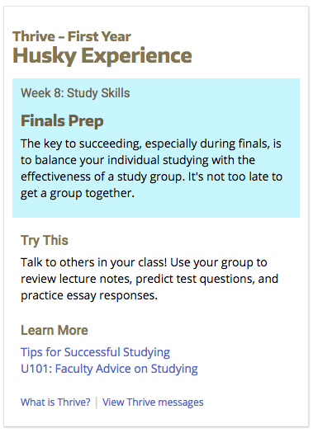

Figure 7. Thrive Message Archive
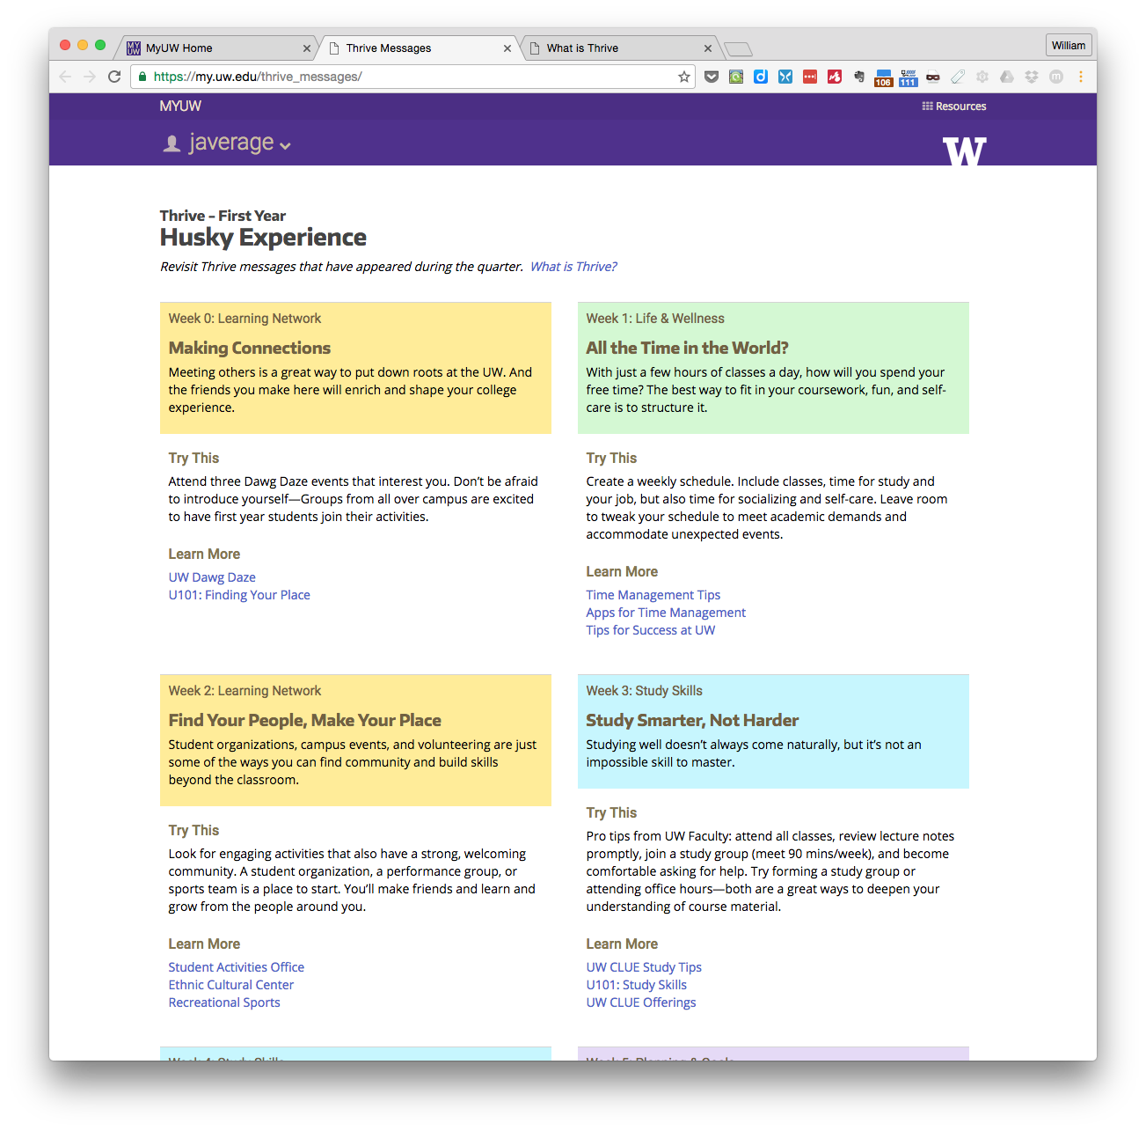

Figure 8. “What is Thrive?” Page

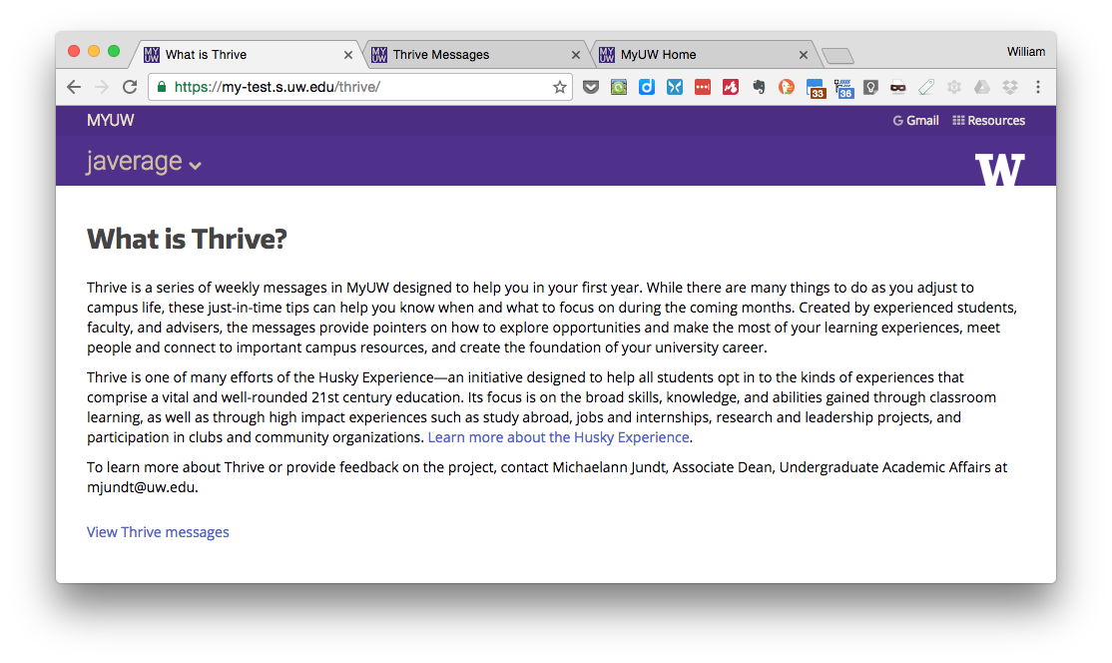

Assessment of the Year 2 effort to deliver Thrive messages to first-year students via MyUW will look much like Year 1. During the third week of spring quarter, all first-year students will receive a survey invitation. The survey will again gather information about whether students read the messages and/or found them to be of value, and will include new questions on value of the message archive and the “What is Thrive?” page. We will also collect log data on MyUW and click-throughs to message resources, and for Year 2, we will track whether students visit the two new pages (archive and Thrive explanation).

We hope that the Thrive card redesign and tweaks to message content, along with greater marketing about the Thrive Initiative from UAA, will increase message readership in 2016-2017. A greater number of readers will give us a more valid and reliable understanding of the success of this effort in achieving its goals for first-year students.

Appendix: Student Survey – Thrive Messages in MyUW

MyUW Thrive Messages

Weekly messages in MyUW under the heading “#ThriveUW” include tips, resources, and other information suggested by experienced students, advisers, and faculty.

This goal of this survey is to understand the value of these messages to you as a first year student, and whether MyUW is an effective platform for communicating the message content.

This survey is confidential and should take about 5 minutes to complete.

Twenty-five participants who complete the survey will be randomly chosen to receive $10 credit on their Husky Card.

- About how often do you log in to MyUW?
Less than once a week
About 1-2 times a week
About 3-5 times a week
At least once a day

2. Which of the following is true for you? Select one:
I have read through almost all the Thrive messages in MyUW.
I have read through some of the Thrive messages in MyUW.
I have briefly skimmed the Thrive messages in MyUW.
I did not read, but noticed the Thrive messages in MyUW. (*branch)
I did not notice the Thrive messages in MyUW. (*branch)

[page break]

3. Thrive messages from Autumn and Winter addressed the following topics and tips. Which messages, if any, do you remember being helpful?
Select all that apply.
Making Connections—how to make friends and connect to other students
All the Time in the World?—time management
Learning Happens Everywhere!—engaging in activities, events, and other opportunities
Librarians: Academic Superheroes—how librarians can help with research
Study Smarter, Not Harder—study strategies and advice
Advisers Can Help!—how to use an adviser
Feeling Stressed?—stress management
Let Curiosity Be Your Guide—following your interests
Roommate Issues?—dealing with interpersonal conflict
Money, Money, Money—managing money
You’re Almost There!—self-care during finals
Learn to Lead—ways to increase leadership skills
Activate Your Activism—getting involved for a cause
Research Smarter, Not harder—using the library’s research guides
Internships and Exploration — finding the right internship
Revisiting Plans, Exploring Options — deciding on a major
Battle the Winter Blues — how to boost mental and physical health
What’s Your Dream Summer? — investigating options for summer
Finals: Pace Your Prep—study strategies for finals
All of these
None of these

4. Which messages, if any, would you want to be able to access and read again?
Making Connections—how to make friends and connect to other students
All the Time in the World?—time management
Learning Happens Everywhere!—engaging in activities, events, and other opportunities
Librarians: Academic Superheroes—how librarians can help with research
Study Smarter, Not Harder—study strategies and advice
Advisers Can Help!—how to use an adviser
Feeling Stressed?—stress management
Let Curiosity Be Your Guide—following your interests
Roommate Issues?—dealing with interpersonal conflict
Money, Money, Money—managing money
You’re Almost There!—self-care during finals
All of these
None of these

[page break]

5. What actions, if any, have you taken in response to the Thrive messages in MyUW? Select all that apply.
I tried a suggestion included in a message.
I clicked on a link in a message.
I told someone else about what I read in a message.
I posted to the #ThriveUW tagboard or another social media platform.
Other: (please specify)
I have not taken any action in response to the Thrive messages.

6. How would you rate the value of the content (tips, resources, information) included in Thrive messages?
Very helpful—Good advice and information
*Somewhat helpful—I’ve found some information I could use
*Not helpful—Advice did not help me, or was not relevant
*Annoying—I was turned off by the content

*6a. Do you have any suggestions for improving the content of Thrive messages so that they are better written or more relevant to your experience?

7. How would you describe the timing of each Thrive message within the quarter?
Well-timed—The messages were delivered at the right time for me to make good use of them.
*Somewhat well-timed—Only in some cases were the messages delivered at the right time for me to make good use of them.
*Not well-timed—The messages were not delivered at the right time for me to make good use of them.
*Didn’t notice — I did not notice a link between the content of each message and when it was delivered.

*7a. Do you have any suggestions for improving the timing of Thrive messages so that you are able to make good use of the information they provide?

8. Thrive messages in MyUW include the following parts:
[EXAMPLE with call-outs]
Header—Grab attention and announce topic
Message—Introduce issue being addressed
“Try This”—Actions you can take in response to issue
Learn More—Links to resources with more info

Do you have any suggestions for improving the format of Thrive messages in MyUW?

[page break]

9. In what other places or from what people have you seen/heard information and advice similar to the content in Thrive messages?
Select all that apply.
Residence Hall Advisers
FIG Leaders
Academic Advisers
Faculty or TAs
Libraries/Librarians
U101 course and videos
Advising and Orientation
Other: (please specify)
I have seen this type of information and advice only in the Thrive messages.

10. Where would you like to receive Thrive messages?
In MyUW (existing channel)
In MyUW, and also ________ (please specify)
Not in MyUW, but in ________ (please specify)
Nowhere; I do not find value in the Thrive messages and would unsubscribe if I could

11. Is there anything more we should know about your experience with the Thrive messages in MyUW?

12. Select all that describe you:
I lived in a residence hall Autumn quarter
I was part of a First-year Interest Group (FIG)

13. Your UW NetID:
(Optional)

Thank you for your feedback!

_________________________

*Branching: Students who indicated in Q2 that they noticed but did not read, or did not notice the messages in MyUW branch to the following questions:

3. Thrive messages from Autumn and Winter addressed the following topics and tips. Which messages, if any, would you want to be able to access and read now?
Select all that apply.
Making Connections—how to make friends and connect to other students
All the Time in the World?—time management
Learning Happens Everywhere!—engaging in activities, events, and other opportunities
Librarians: Academic Superheroes—how librarians can help with research
Study Smarter, Not Harder—study strategies and advice
Advisers Can Help!—how to use an adviser
Feeling Stressed?—stress management
Let Curiosity Be Your Guide—following your interests
Roommate Issues?—dealing with interpersonal conflict
Money, Money, Money—managing money
You’re Almost There!—self-care during finals
Learn to Lead—ways to increase leadership skills
Activate Your Activism—getting involved for a cause
Research Smarter, Not harder—using the library’s research guides
Internships and Exploration—finding the right internship
Revisiting Plans, Exploring Options—deciding on a major
Battle the Winter Blues—how to boost mental and physical health
What’s Your Dream Summer?—investigating options for summer
Finals: Pace Your Prep—study strategies for finals
All of these
None of these

4. Based on the list above, in what other places or from what people have you seen/heard information and advice similar to the content in Thrive messages?
Select all that apply.
Residence Hall Advisers
FIG Leaders
Academic Advisers
Faculty or TAs
Libraries/Librarians
U101 course and videos
Advising and Orientation
Other: (please specify)
I have seen this type of information and advice only in the Thrive messages.

5. Thrive messages in MyUW include the following parts:
[EXAMPLE with call-outs]
Header—Grab attention and announce topic
Message—Introduce issue being addressed
“Try This”—Actions you can take in response to issue
Learn More—Links to resources with more info
How could the format of Thrive messages in MyUW be improved to encourage students to read them?

[page break]

6. Is there a better way for you to receive helpful tips and advice than in MyUW?

Please explain.

7. Is there anything more we should know about your experience with the Thrive messages in MyUW?

8. Select all that describe you:
I lived in a residence hall Autumn quarter
I was part of a First-year Interest Group (FIG)

9. Your UW NetID:
(Optional)

Thank you for your feedback!

